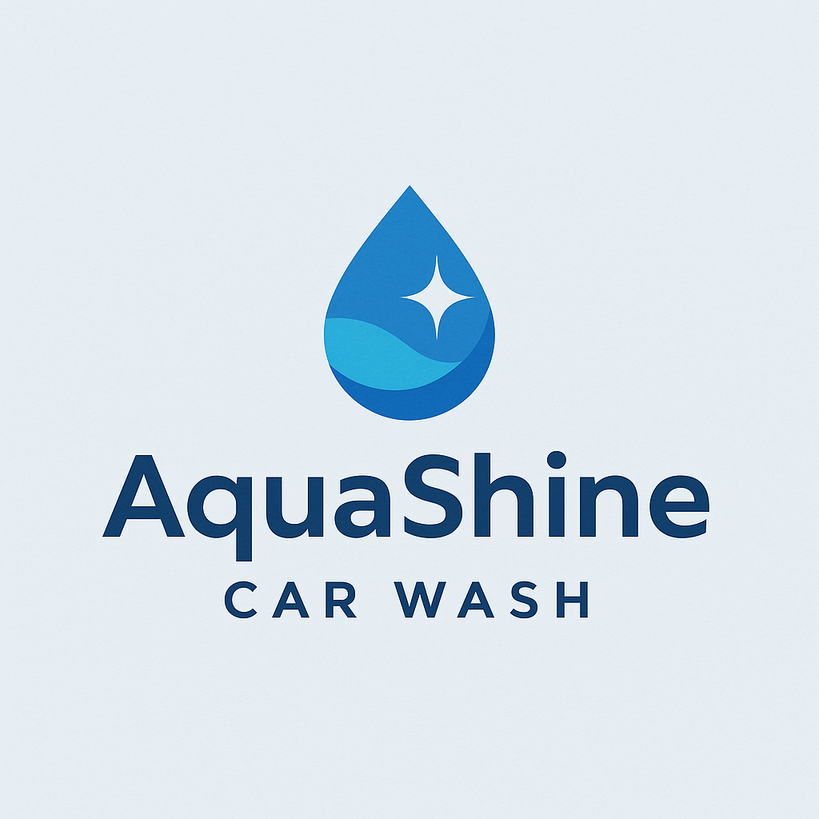

Business Plan: AquaShine Car Wash

Executive Summary

Business Name : AquaShine Car Wash
Location : Cape Town (site to be finalized)
Services Offered :
Comprehensive vehicle cleaning including hand washing, automated washing, meticulous detailing, full valet services, engine bay cleaning, deep upholstery cleaning, crystal-clear window cleaning, and innovative waterless wash alternatives.
Target Market :
Our services are designed for discerning vehicle owners in middle- to high-income residential areas, busy ride-hailing service drivers (Uber/Bolt), commercial logistics fleets, and both private individuals and corporate clientele.

Business Model :
We will offer a flexible service model including walk-in appointments, value-driven monthly memberships, and customizable bulk packages for fleet clients.
AquaShine Car Wash is poised to deliver premium, efficient, and environmentally responsible vehicle cleaning solutions throughout strategic Cape Town locales. By integrating customer convenience, superior service experiences, and expert detailing, we aim to satisfy the evolving needs of the city's expanding car-owning demographic and promote sustainable car care practices.

Market Analysis

Industry Overview:
The vehicle cleaning industry in Cape Town is on an upward trajectory, fueled by a growing number of vehicles on the road, greater emphasis on vehicle upkeep, and a preference for quick, eco-aware cleaning options. There's a notable consumer shift towards comprehensive services that cover interior detailing, upholstery rejuvenation, and thorough window care.

Target Market Segments:
Our primary clientele includes:
- Vehicle owners in middle-to upper-income suburban areas who value convenience and demand premium care for their cars.
- Drivers for e-hailing (Uber/Bolt) and delivery services seeking regular, cost-effective cleaning solutions.
- Operators of vehicle fleets (including corporate fleets, car rental agencies, educational institutions, and security companies) requiring dependable and consistent vehicle maintenance.
- Individuals frequenting commercial districts (shoppers and employees) who can utilize our services conveniently during their activities.
- Private individuals and corporate clients seeking specialized upholstery and window cleaning services.

Target Areas for Launch:
- Claremont/Newlands : Affluent suburb with private vehicle saturation
- Bellville : Proximity to business parks and transit hubs
- Parow/Cape Town CBD : High-traffic zones ideal for visibility and footfall
- Sea Point : Expanding market with accessible pricing packages
- Century City: Ideal for mall shoppers and nearby office parks

Services & Pricing

Service Type | Price Range (ZAR)
Basic Exterior Wash | R70 – R100
Full Valet (Comprehensive Interior & Exterior) | R350 – R600
Engine Bay Cleaning | R150 – R200
Wax & Polish Application | R300 – R500
Deep Upholstery Cleaning | R250 – R400
Interior & Exterior Window Cleaning | R100 – R150
Waterless Wash (Eco-Friendly Option) | R90 – R130
Monthly Membership Packages | R400 – R700
Customized Fleet Service Packages | Price on Request

Additionally, specialized service packages will be tailored for ride-hailing professionals (Uber/Bolt) and loyal patrons.

Marketing & Sales Strategy

Our multi-faceted marketing and sales approach will involve:
- Targeted Local Engagement:
Distributing promotional materials like flyers at petrol stations and within local business parks.
- Strong Digital Footprint:
Optimizing our online visibility through Google My Business, maintaining an active presence on social media platforms (Facebook/Instagram), and engaging with community WhatsApp groups.
- Compelling Launch Campaigns:
Generating initial customer interest with offers such as complimentary or discounted first-time washes, loyalty card programs, and referral reward schemes.
- Strategic Alliances:
Collaborating with ride-hailing service providers, logistics companies, shopping centres, and corporate entities to expand our reach.
- Proactive Customer Retention:
Cultivating long-term customer relationships via a dedicated loyalty application, offering value-added service bundles, and consistently refining our services based on customer feedback.

Operations Plan
Operating Hours:
We will operate seven days a week, from 7:00 AM to 6:00 PM, ensuring accessibility for our diverse clientele.

Staffing Structure:
Each site will be efficiently managed by a dedicated Site Manager, supported by a skilled team of 3 to 5 Car Wash Technicians.

Key Facility Features:
- Comfortable, shaded service bays providing an optimal environment for vehicle cleaning.
- A welcoming customer waiting lounge equipped with complimentary Wi-Fi and refreshments.
- An advanced, eco-friendly water management system to minimize environmental impact.

Essential Equipment:
- Industrial-grade high-pressure washing units for effective exterior cleaning.
- Specialized steam and vacuum cleaners designed for deep upholstery and interior cleaning.
- Professional-grade kits and solutions for immaculate glass and window detailing.
- High-quality orbital polishers and a comprehensive range of premium car care products.
- A modern Point of Sale (POS) system to facilitate seamless digital payments and record-keeping.

Water Conservation Strategy:
Our water conservation strategy will prioritize the use of innovative waterless wash products and explore the implementation of on-site greywater recycling systems. These measures will significantly reduce water consumption and champion our commitment to environmental sustainability.

Financial Projections (Year 1)
Initial financial forecasts for the first year of operation are as follows:

Anticipated Revenue Streams:

Revenue Stream | Projected Monthly (ZAR) | Projected Annual (ZAR)
Standard Exterior Washes (approx. 20 per day) | R42,000 | R504,000
Full Valets & Detailing Services (approx. 10 per week) | R18,000 | R216,000
Upholstery/Window Cleaning (approx. 10 per day) | R25,000 | R300,000
Monthly Membership Subscriptions (30–40 clients) | R18,000 | R216,000
Total Projected Revenue | R103,000 | R1,236,000

Estimated Monthly Operational Expenditures

Expense Category | Estimated Amount (ZAR)
Site Lease/Rental Costs | R10,000 – R15,000
Staff Salaries & Wages | R25,000
Utilities (Water & Electricity) | R2,000
Cleaning Products & Consumables | R6,000
Equipment Maintenance & Repairs | R1,500
Marketing & Administrative Costs | R2,000
Total Estimated Monthly Expenses | ~R51,500

We project an Estimated Net Monthly Profit ranging from R30,000 to R45,000, commencing from the sixth month of operation.

Next Steps & Support Required
To ensure a successful launch and facilitate sustained growth for AquaShine Car Wash, the following immediate actions and support mechanisms are crucial:

Critical Immediate Needs:
- Securing and finalizing lease agreements for prime operational locations.
- Sourcing and procuring all essential cleaning equipment and environmentally friendly supplies.
- Developing a compelling and recognizable brand identity, including professional signage and marketing collateral.
- Recruiting qualified staff and providing them with comprehensive foundational skills training.
- Implementing a robust digital infrastructure to manage bookings, process payments, and oversee customer relationship management (CRM).
- Exploring micro-financing opportunities or engaging with potential investors to secure the necessary startup capital.

